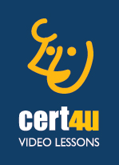cert4u video lessons

cert4u® video lessons are the best proposal. They provide:

* high aesthetics environment
* professional pronunciation and recording,
* full coverage of the material and
* connection to TEST4U